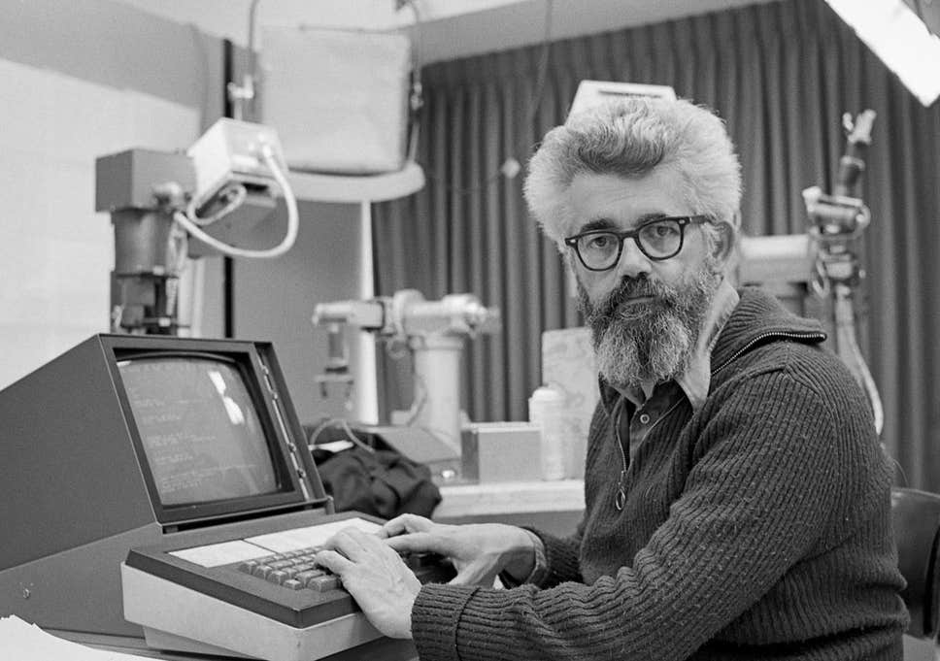

John McCarty was an American computer scientist and cognitive scientist. McCarty made huge contributions to computer science during his life. He is a co-founder of artificial intelligence and timesharing systems as well as creating his own programming language. He has received many honours for his work, including a Turing award in 1971. Much of McCarthy’s work still has great influence in the modern world.

## Early Life:

John McCarthy was born on September 4th, 1927, in Boston to an Irish immigrant father and a Lithuanian immigrant mother. John and his family later relocated to California due to the Great Depression. From an early age McCarthy showed incredible intelligence and aptitude for maths. He graduated from Belmont High School two years early. During his time at Belmont he fed his passion for maths by studying the textbooks used by the nearby colleges and as a result when he was accepted in to Caltech in 1944 aged just 17 he was permitted to skip the first 2 years of their mathematics course. It was at Caltech where McCarthy attended a lecture by John von Neumann which inspired his future work. McCarthy completed his ungraduated studies at Caltech before moving to Princeton where he received his Ph.D in mathematics in 1951. After spending time in both Dartmouth and MIT as an assistant professor he then became a full professor at Stanford in 1962, where he remained until his retirement in 2000.

## Dartmouth Conference:

During his time at Dartmouth, McCarthy organised a ground -breaking conference on artificial intelligence, and it was here that the term artificial intelligence was first coined. Before the conference there was believed to be various names for the field of “thinking machines”: cybernetics, automata theory and complex information processing. The variety of names suggests there was a lack of continuity in the subject. So, in 1956 McCarthy organised a 2-month, 10-man study of artificial intelligence.

*“The study is to proceed on the basis of the conjecture that every aspect of learning or any other feature of intelligence can in principle be so precisely described that a machine can be made to simulate it. An attempt will be made to find how to make machines use language, form abstractions and concepts, solve kinds of problems now reserved for humans, and improve themselves.”*

It was during the conference that McCarthy met Marvin Minsky, who later became one of the leading theorists in the field. McCarthy and Minsky both joined forces at MIT in 1959 where they founded the MIT Artificial Intelligence Laboratory. However their views on the topic later started to diverge and McCarthy decided to return to Stanford where he founded SAIL; Stanford’s AI Laboratory, which became MIT’s rival.

## Lisp:

McCarthy invented the computer programming language Lisp in the late 1950s, while at MIT. He published its design in a paper in 1960. He showed that with a few simple operators and a notation for functions, one can build a Turing-compete language for algorithms. Based on the lambda calculus, Lisp soon became the programming language of choice for AI applications after its publication in 1960. Today Lisp is the second oldest widespread used high functioning programming language. Lisp has pioneered many pivotal ideas in programming such as tree data structures, recursion and higher order functions. Lisps is still used in AI programming, robotics as well as a wide array of internet based services. Lisp is believed to have paved the way for voice recognition technology’s such as Apple’s Siri.

Also around the time he published Lisp, he invented a method called ‘garbage collection’ to solve problems in Lisp. Garbage collection attempts to reclaim garbage or memory occupied by objects that are no longer in use by the program. This idea is still used in many languages to this day.

## Time sharing:

McCarthy played a large role in the development of 3 of the earliest time sharing systems: Compatible Time-Sharing System, BBN Time-Sharing System and Dartmouth Time-Sharing System. Time-sharing is a technique which enables many people, located at various terminals, to use a particular computer system at the same time.

Ex-colleague Lester Earnest explains the importance of McCarthy’s time sharing work: *"The Internet would not have happened nearly as soon as it did except for the fact that John initiated the development of time-sharing systems. We keep inventing new names for time-sharing. It came to be called servers ... Now we call it cloud computing. That is still just time-sharing. John started it."*

## SAIL:

During the 1960s and '70s, the Stanford lab played a pivotal role in creating the systems that mimic many human skills, including vision, listening, reasoning and movement. McCarthy sometimes showcased inventions and invited the Homebrew Computer Club, a Silicon Valley hobbyist group, to meet at the Stanford labs. The group included two of Apple's founding members, Steve Jobs and Steven Wozniak. In the 1970s, McCarthy presented a paper on buying and selling via computer, foreseeing e-commerce.

One of SAILs most successful students was Alan Kay who, after studying at SAIL he

moved to Palo Alto Research centre where he invented object-oriented programming. He credited McCarthy and Lisp as a major influence and has called Lisp the "greatest single programming language ever designed."

## Conclusion:

McCarthy officially retired from Sandford in 1994 but continued to write and lecture up until his death in 2011. Throughout the college he was affectionally referred to as ‘Uncle John’ and was known to always be kind and generous with his time. McCarthy received many awards and honours throughout his life time including: Turing Award 1971, Kyoto Prize 1988, National Medal of Science 1990, Benjamin Franklin Medal in Computer and Cognitive Science 2003 and inducted in the Computer History museum and IEEE Intelligent Systems’ AI’s Hall of Fame. As well as being named as one of the 2012 Standford Engineering Hero’s. Many of his contributions still have major significance to this day.

References:

<https://en.wikipedia.org/wiki/John_McCarthy_(computer_scientist)>

<https://en.wikipedia.org/wiki/John_von_Neumann>

<https://www.independent.co.uk/news/obituaries/john-mccarthy-computer-scientist-known-as-the-father-of-ai-6255307.html>

<https://history.computer.org/pioneers/mccarthy.html>

<https://en.wikipedia.org/wiki/Dartmouth_workshop>

<https://en.wikipedia.org/wiki/Garbage_collection_(computer_science)>

<https://www.wired.com/2011/10/john-mccarthy-father-of-ai-and-lisp-dies-at-84/>

<https://www.tutorialspoint.com/operating_system/os_types.htm>